To choose column check the checkbox and click on save button to complete

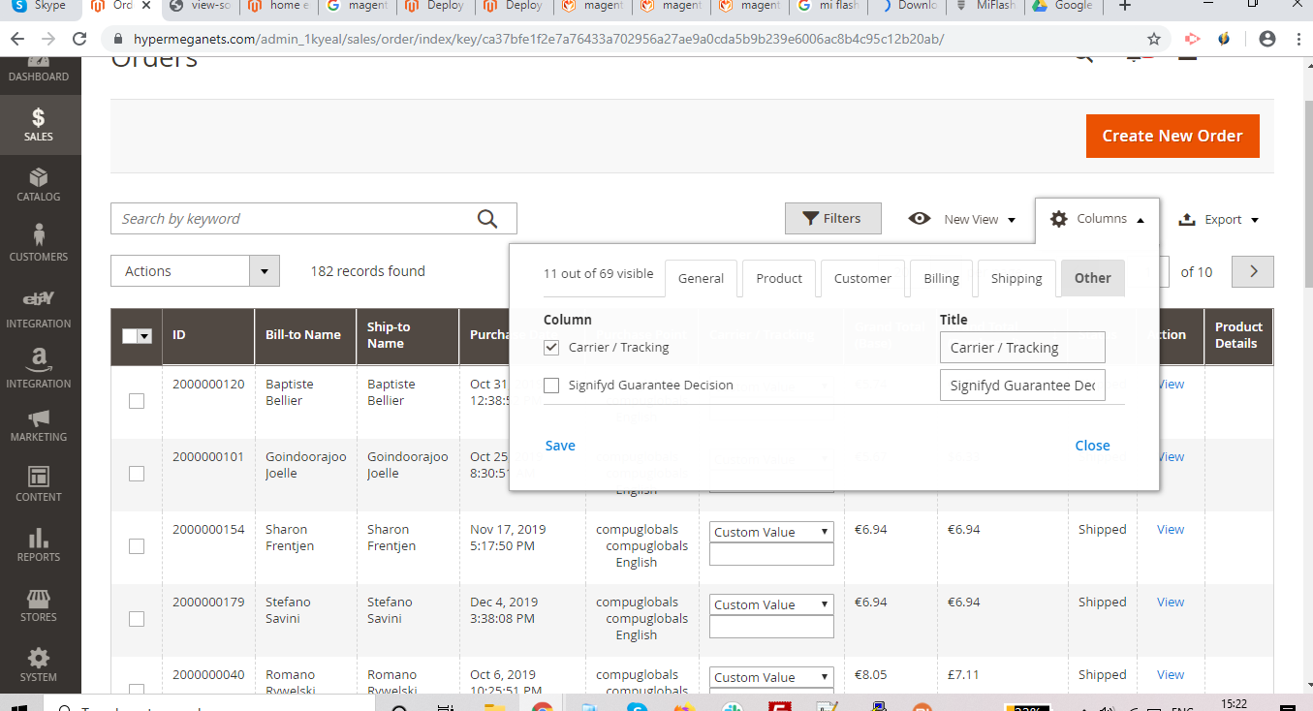
You can simply drag and drop the column where you want to place them
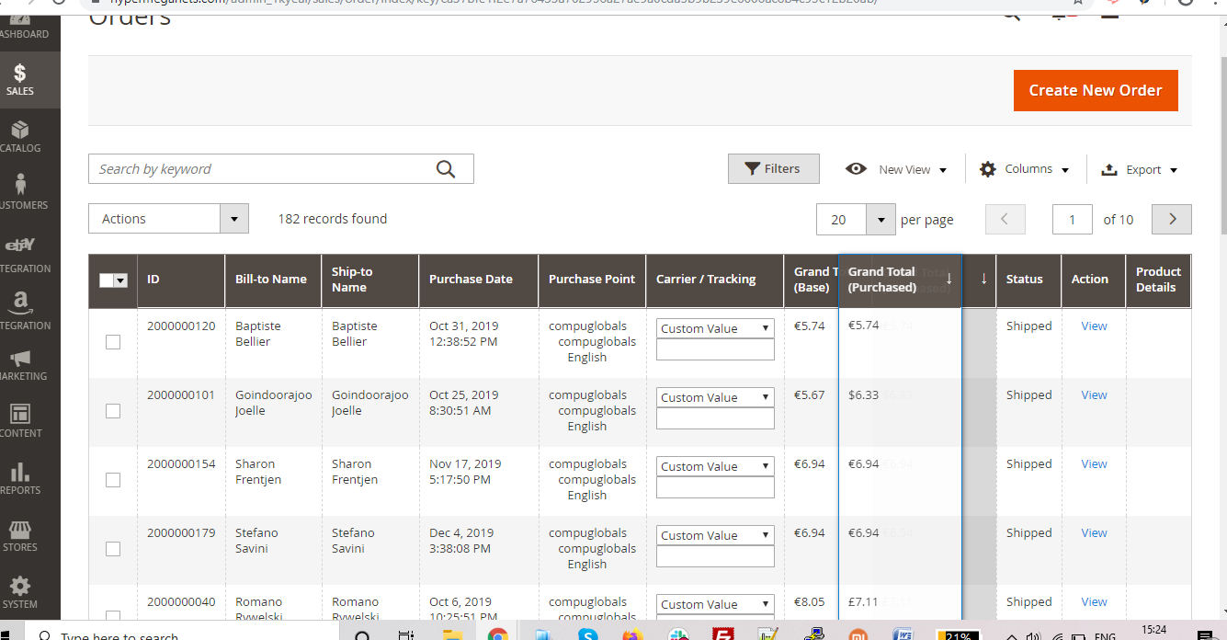
Then the location of the column will change according to the need
